**Day 02 Of Hackathon 3 Planning The Technical Foundation**

**Introduction:**

My E-Commerce website your one-stop destination for trendy women's clothing, stylish men's apparel, and must-have accessories. Discover fashion that fits your lifestyle, crafted with quality and designed to impress. Our Marketplace aims to provide high-quality, affordable, and stylish clothing and accessories for men and women.

**1.Define Technical Requirements.**

**1.Frontend Requirements.**

* **Framework:**
* For Framework we use Next.js for dynamic UI and server-side rendering.
* **Styling:**
* For Styling we use Tailwind CSS for dynamic UI and server-side rendering**.**
* **Responsive Design:**
* Mobile, tablet, and desktop compatibility.
* **Pages Included:**
* Homepage, Shop, Products, Product Details, About, Team, Contact, Price, Login/Register, Cart, Wishlist, Checkout, Order Confirmation, Tracking.

**2.Sanity CMS as Backend.**

Use Sanity CMS to manage product data, customer details, and order records. Sanity acts as the database.

**3.** **Third-Party APIs.**

Integrate APIs for shipment tracking, payment gateways, and other required backend services.

**2.** **Design System Architecture**

Creating a diagram to show how system components interact below.

**User**

**Shipment Tracking API**

**Product Data API**

**Payment Gateway**

**Third-Party API**

**Sanity CMS**

**Frontend (Next.js)**

* **Components Interact:**

**Frontend Next.js:** Frontend Next.js Interact by sharing data via props, context, and state, while fetching dynamic content through API calls.

**Sanity CMS**: Sanity CMS interacts by providing real-time content via APIs, allowing frontend frameworks to fetch, manage, and display structured data dynamically.

**Third party API**: Third-party APIs interact by sending HTTP requests (GET, POST, etc.) and receiving responses (JSON/XML) to exchange data between systems.

**Payment Gateway**: Payment gateways interact by securely processing payment details from the frontend and returning transaction statuses via API responses.

* **Key Workflows**

**1.Product Browsing**: Users search for products or navigate through categories, view product details, and filter results.

**2.Adding to Cart**: Users select products, specify quantity or size, and add them to the shopping cart.

**3.Order Placement**: Users proceed to checkout, provide shipping information, choose a payment method, and confirm the order.

**4.Shipment Tracking:** Users receive tracking information post-order placement and can track the status of their shipment in real-time.

|  |  |  |  |
| --- | --- | --- | --- |
| **Endpoints** | **Method** | **Description** | **Response Example** |
| **/products** | **GET** | **Fetch products details** | **{“id”: 1,**  **“name”: ”T-shirt”, “category”: “men’s wear”,**  **“price”: 1000,**  **“Description”: “Stylish Men’s Wear”**  **“stock”: 50,**  **“image”: shirt.png”,}** |
| **/order** | **POST** | **Place a order** | **{“orderId”: 34569,**  **“productId”: 1,**  **“Quantity”: 2,**  **“payment”: 2000,**  **“totalAmount”: 2500,**  **“userId”: 123}** |
| **/customer** | **POST** | **Register/Update customer details** | **{“customerId”: 566,**  **“address”: “xyz”,**  **“contactNumber”: 0315557687,**  **“Name”: “Asiya”,**  **“orderHistory”: “Order Confirmed”}** |
| **/deliveryZone** | **GET** | **Fetch updates of delivery zone** | **{“zoneName”: “latifabad”,**  **“coverageArea”: 1567,**  **“assignedDriver”: “leopard”}** |
| **api/shipment** | **GET** | **Track the status of Shipment** | **{“orderId”: 34569,**  **“shipmentId”: 1566767878,**  **“status”: “Delivered”,**  **“deliveryDate”: 2025-02-28}** |

**3.** **Sanity Schema**

Product Schema:

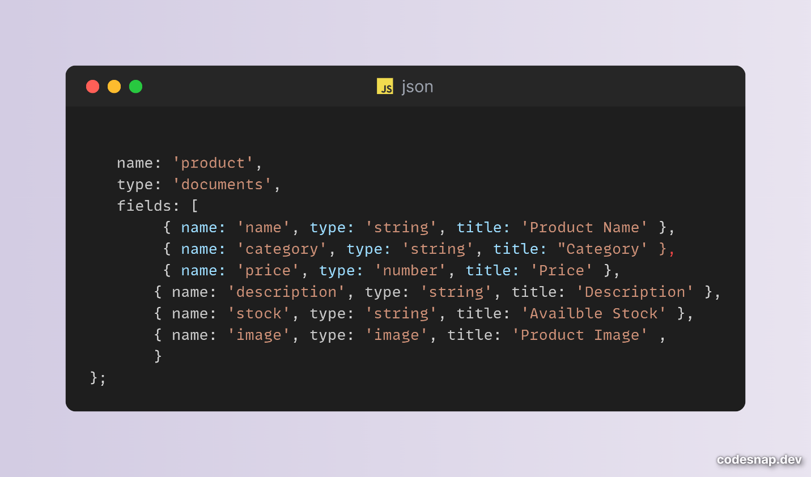

Customer Schema:

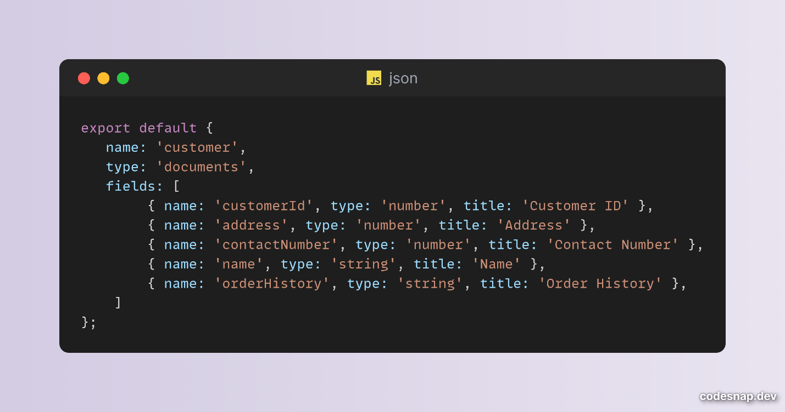

Order Schema:

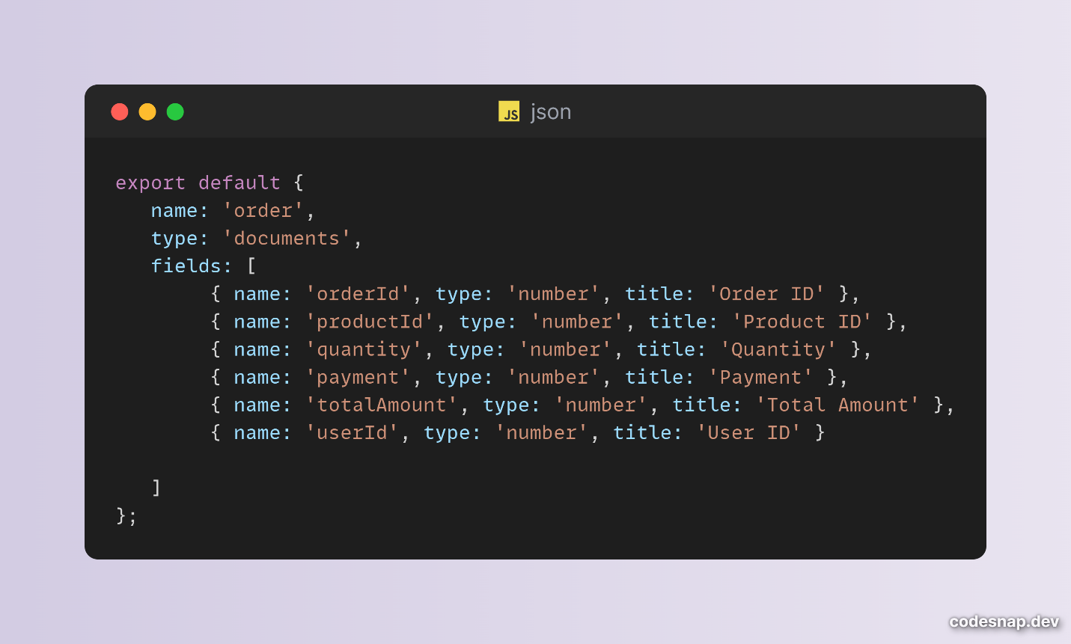

**MADE BY: ASIYA KHAN**